ESC Member Federations
Dear Colleagues, it is my pleasure to inform You about the new decision of 25m Lapua European Cup competitions at year 2021.
We are not organizing Final 2020 at Lisbon 9.-11.4.2021 because of Covid. We try to organize 4 qualification rounds to be hold between April 2021 and August 2021 and the Final in September 2021. Final 2020 will be shot at the same weekend as Final 2021.
Because of COVID-19 I recommend that all qualification competition will be shot at every second firing point by having more relays than usually. Also, organizers need to provide disinfection and cleaning facilities for athletes and officials.
If there will be cancellations of qualification competitions, ESC pistol committee will pick athletes to Final from waiting list.

Sincerely

Marko Leppä
Member of the ESC Technical Committee (pistol)
Leväpolku 1
49400 Hamina

Finland
+358 40 510 5323
marko.leppa@ampumaurheiluliitto.fi

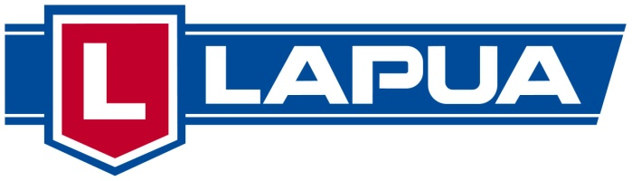
Information of the LAPUA EUROPEAN CUP 25m 2021

Center Fire Pistol - and Standard Pistol
The European Cup 25m is a tournament in non Olympic events. ESC also wants to offer for Center Fire Pistol and Standard Pistol shooters a possibility to participate at additional events. Four qualification competitions and the final will be arranged as follow:

1. The first qualification round

will be organized by the German Shooting Sport Federation - Deutscher Schützenbund e.V. in Suhl (GER) 23. – 25.04.2021
www.schuetzenbund.de, brokamp@dsb.de

- The second qualification round

will be organized by the Danish Shooting Union in – Dansk Skytte Union
in Aarhus (DEN) 11. – 13.06.2021
www.skytteunion.dk , info@skytteunion.dk

- The third qualification round

will be organized by the Estonian Shooting Federation – Eesti Laskurliit
in Tallinn (EST) 9. – 11.07.2021

www.laskurliit.ee, info@laskurliit.ee

- The fourth qualification round

will be organized by the Shooting Union of Slovenia – Strelska Zveza Slovenije in Rečica Pri Laškem (SLO) 20. – 22. 08.2021
info@strelska-zveza.si www.strelska-zveza.si

The Final 2020

will be organized by French Shooting Federation - Fédération Française de Tir in Châteuaroux (FRA) from 17. – 18.9.2021
http://www.fftir.org secretariat-general@fftir.org

The Final 2021

will be organized by the French Shooting Federation - Fédération Française de Tir in Châteuaroux (FRA) from 18. – 19.9.2021
http://www.fftir.org secretariat-general@fftir.org

