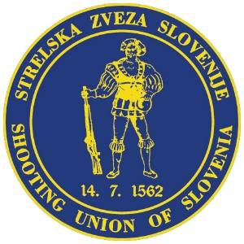


LAPUA EUROPEAN CUP
25 m PISTOL

20. - 22. 8. 2021
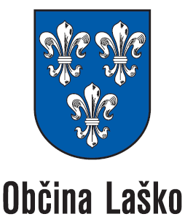
Laško / Slovenia

final HOTEL ENTRY FORM

Rates for rooms in Hotel Špica: Single room 56 € per night per person including breakfast

Double room 36 € per night per person including breakfast

Country: | Contact person:
Address: | Telephone:
E-Mail:

Name | Date for arrival | Date for departure | rooms
 |  |  | Double
 |  |  | Double
 |  |  | Double
 |  |  | Double
 |  |  | Double
 |  |  | Single
 |  |  | Single
 |  |  | Suite
We will confirm your reservation.
Please send this “Hotel Entry Form” NOT LATER THAN 01. August 2021 to the following E-mail address: andrej.brunsek@gmail.com

