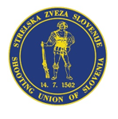

LAPUA EUROPEAN CUP
25 m PISTOL
26. - 28. 8. 2022
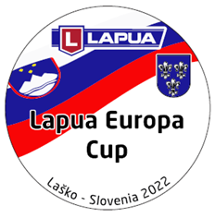
Laško / Slovenia

PRELIMINARY ENTRY FORM
Country
Contact person
E-mail
Phone
Address

Participants:
 | Male | Female | Center Fire Pistol | Standard Pistol
Number of athletes
Number of officials

Banquette evening:
Saturday evening
3-course menu and 2 dcl of wine or draft beer
(20 € p.P.)
Number of participants
comment

Transportation:
We arrive by... (x) | Airplane | Train | Bus | Car

Arrival by Flight at day and time |  |  | Flight-No. |  | Number of people
Departure by Flight at day and time |  |  | Flight-No. |  | Number of people

Date | Signature

Please send this “Preliminary Entry Form” NOT LATER THAN 1st August 2022 to the following E-mail address: andrej.brunsek@gmail.com

