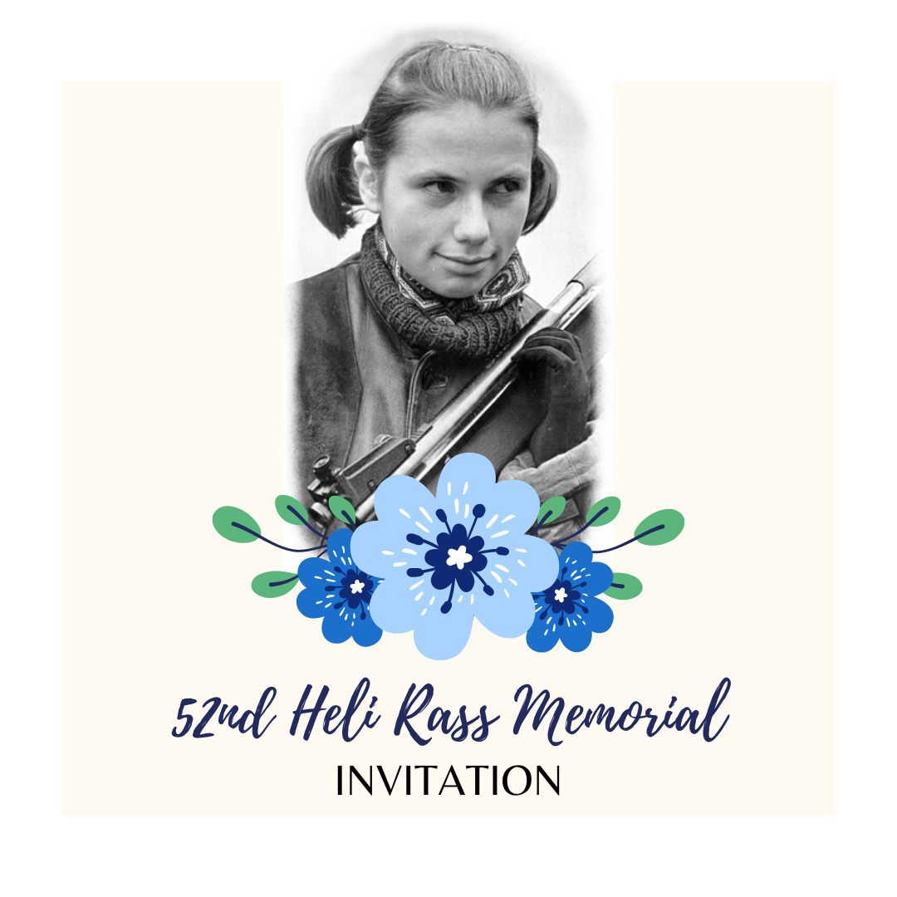
Dear shooters and coaches

Elva Shooting Sport Club and competition organizing committee invites you all to the beloved international shooting competition – 52nd Heli Rass Memorial from 26th – 28th April 2024 in Elva Shooting Sport Centre!

Heli Rass was a young talented shooter from Elva who died of leukemia at the age of 21, having by that time become the best female rifle shooter in Estonia, setting Estonian records and winning title competitions. In her honour and memory, commemorative competitions have been organized in Elva since 1973, and they have become the opening competitions of the firearms season of Estonian shooting sports.

Please see the competition general information and schedule below. For registering your entries, please use entry form given by the organizers and send it to elvalask@gmail.com.

Elva Shooting Sport Club
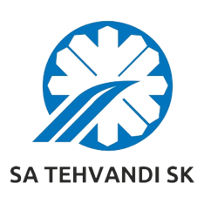
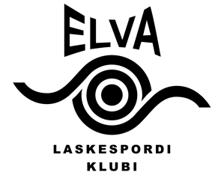

52nd international Heli Rass Memorial

Tartumaa Tervisespordikeskus, Elva, Estonia

26th – 28th april 2024

GENERAL INFORMATION

SCHEDULE

Friday, 26.04.2024
13.00 25 m military rapid-fire pistol 3x20 shots (M, cal .32), (W, cal .22)
15.00 50 m pistol 60 shots Open (M, W) and Open Junior (MJ, WJ) (Sius)
10 m air rifle 60 shots W, WJ (Sius)

Saturday, 27.04.2024
8.30 Opening ceremony
9.00 25 m standard pistol 20+20+20 shots (M, MJ, W, WJ)
10.00 50 m rifle prone 60 shots (W, WJ) (Sius)
50 m Running Target 30+30 shots (M, W)
11.00 10 m air pistol, air rifle 60 shots (W, WJ) (Sius)
12.00 25 m rapid fire pistol 30+30 shots (M, MJ)
13.00 50 m rifle 3x20 shots (M, MJ) (Sius)
17.00 50 m rifle final (M, MJ) (Sius)
18.00 25 m rapid fire pistol final (M, MJ)
20.00 Awarding ceremony

Sunday, 28.04.2024
9.00 10 m air pistol 60 shots (W, WJ) (Sius)
25 m pistol 30+30 shots (W, WJ, MJ)
25 m centre fire pistol 30+30 shots Open (M, W)
50 m rifle prone 60 shots (M, MJ) (Sius)
50 m Running Target 20+20 shots mix (M, W)
12.00 50 m rifle 3x20 shots (W, WJ) (Sius)
16.00 25 m pistol final (W, WJ)
50 m rifle final (W, WJ) (Sius)
17.30 Awarding and closing ceremony

Starting times indicates the first competition shot. Finals start times may change during the competition.
Results:
Records shall be kept separately for women, men, junior female and junior male (born 2003 and later) age classes. Open event is individual event with male and female athletes competing together in one event. The same applies for Open Junior event, where junior men and junior women athletes are competing individual together in one event. Finals will be held for adults and including juniors as well. In case some of the finalists cannot participate in the final, next shooter from qualification ranking will be called.

Awards:
Three bests from each event in adult and junior age categories will be awarded with competition trophy and diploma. Three bests of the finals will be awarded with special prizes. Two shooters – best female rifle shooter and best result shooter – will be awarded with the nomadic trophy.

The nomadic trophies statute:
With the nomadic trophy “The best women rifle shooter”, issued by the Heli Rass´s parents, will be granted to the best female rifle shooter who obtains the best summary of two small- bore rifle scores (without finals).

With the nomadic trophy “The best result”, issued by the Tartu District Physical culture and Sports Committee in 1973, will be granted to the shooter who obtains the best result in the competition according to the official class standards.

Management:
All travel, entry fees and accommodation expenses shall be paid by the participants.

Entry fees:
15 euros per shooter per event (adults and juniors)

Preliminary Entries:
Not later than 15th of April 2024 by e-mail: elvalask@gmail.com
Please use the entry form given by the organizers.

Information:
Karl Kontor +372 505 4006
Marianne Tavits +372 5569 7021
Lennart Saarepuu +372 5361 0785
Maarja-Liisa Maasik +372 5330 6706
www.elvalask.ee or elvalask@gmail.com

Accommodation:
tel. +372 745 6333 or +372 555 12492
www.tervisesport.ee

Organizers: Elva Shooting Sport Club and Tehvandi Sports Centre

